Export to PNG

300 DPI

Width: ~2000 px

Layer Separation
Remove inputs and outputs.
Just show:
Capture
Processing
Organization
Execution
Review

Failure Mode
Break the flow:
Capture → Processing → ✖ Organization
Add messy outputs.

Maturity Model
Duplicate the stack horizontally.
Ad Hoc → Structured → Integrated → Autonomous

90-Day Roadmap
Replace layers with phases.
Foundation
Stabilization
Optimization

Team Adaptation
Duplicate the stack multiple times.
User A
User B
User C
Add collaboration arrows.

- [X] CH01-MU01 — System Overview Conceptual Diagram

Figure 1. System Overview of the VIRON Method

![System Overview](diagram1.png)

Figure 1. System Overview of the VIRON Method

'/Users/joshuazauderer/My Drive/projects/VIRON/assets/diagrams/CH01-MU01-system-overview.png'

- [X] CH02-MU01 — Layer Separation Diagram

Caption: Figure 2. Separation of Functional Layers in the VIRON System
- [] CH02-MU02 — Layer Interaction Diagram
Figure 3. Interaction Between Functional Layers in the VIRON System

- [X] CH03-MU01 — Notes Sidebar Folder Layout

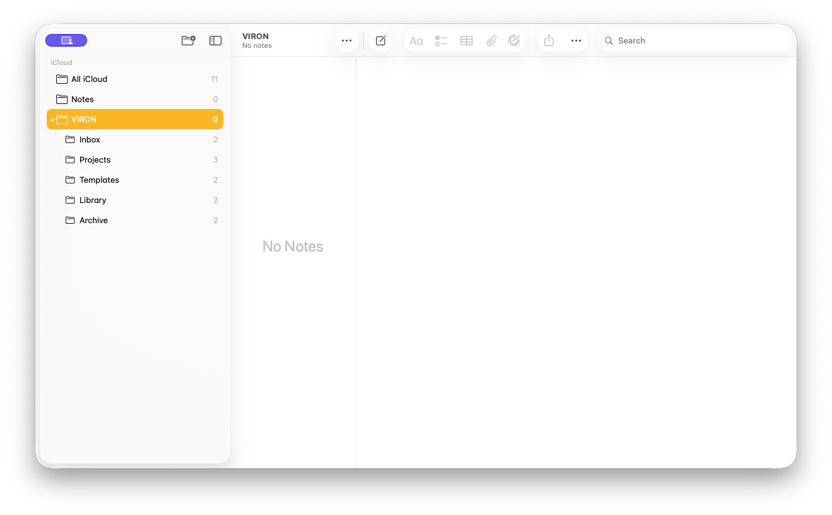

- [X] CH03-MU02 — Idea Inbox Note Structure

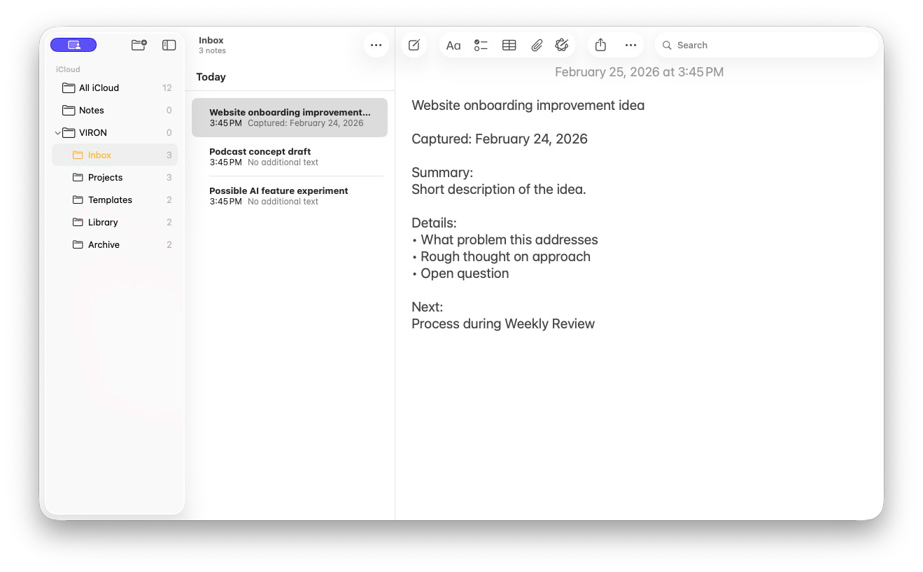

- [X] CH03-MU03 — Projects Folder with 3 Active Projects

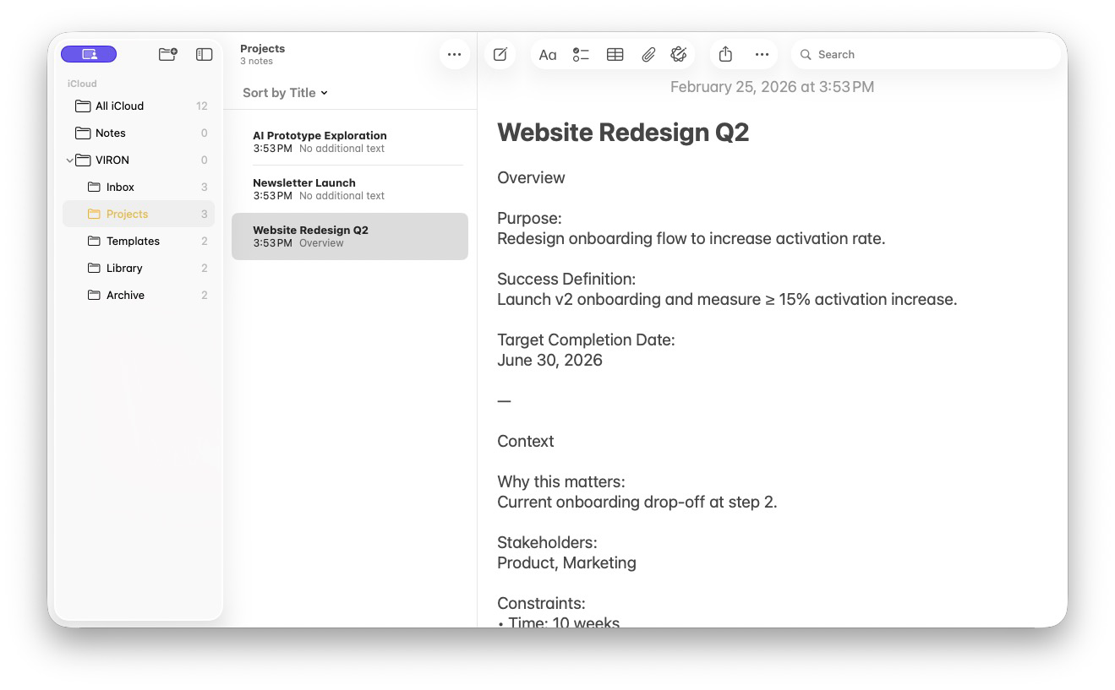

- [X] CH03-MU04 — Library Folder with Atomic Notes

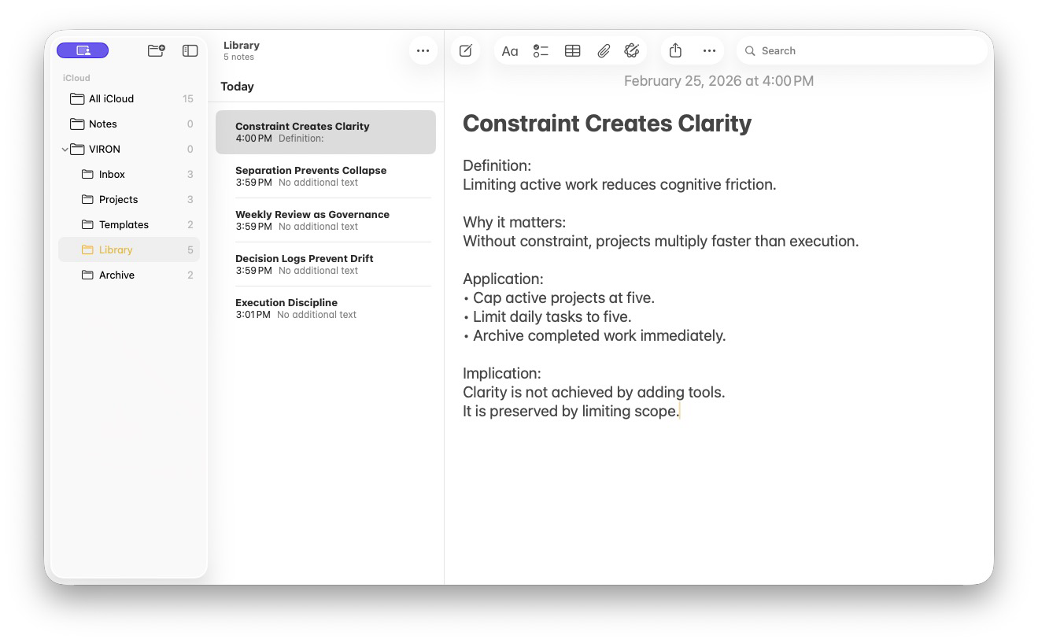

- [X] CH03-MU05 — Notes Settings Configuration

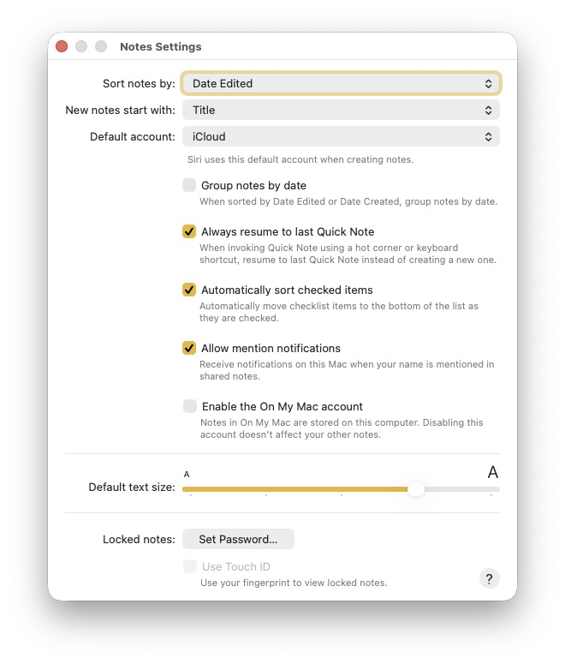

- [X] CH03-MU06 — Apple Intelligence ChatGPT Extension Enabled

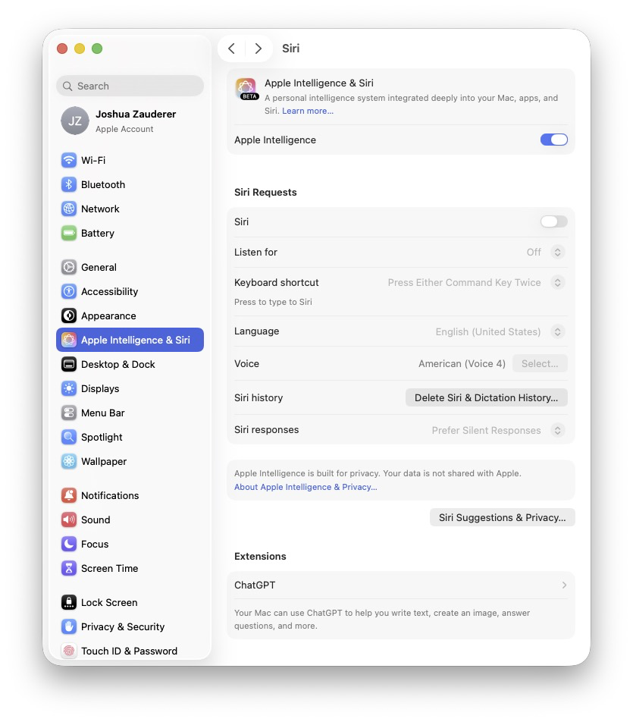

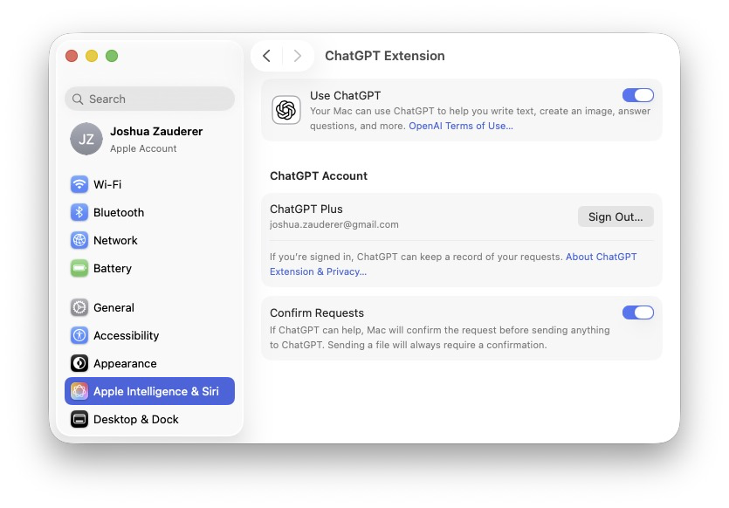

- [X] CH04-MU01 — Clean Reminders List

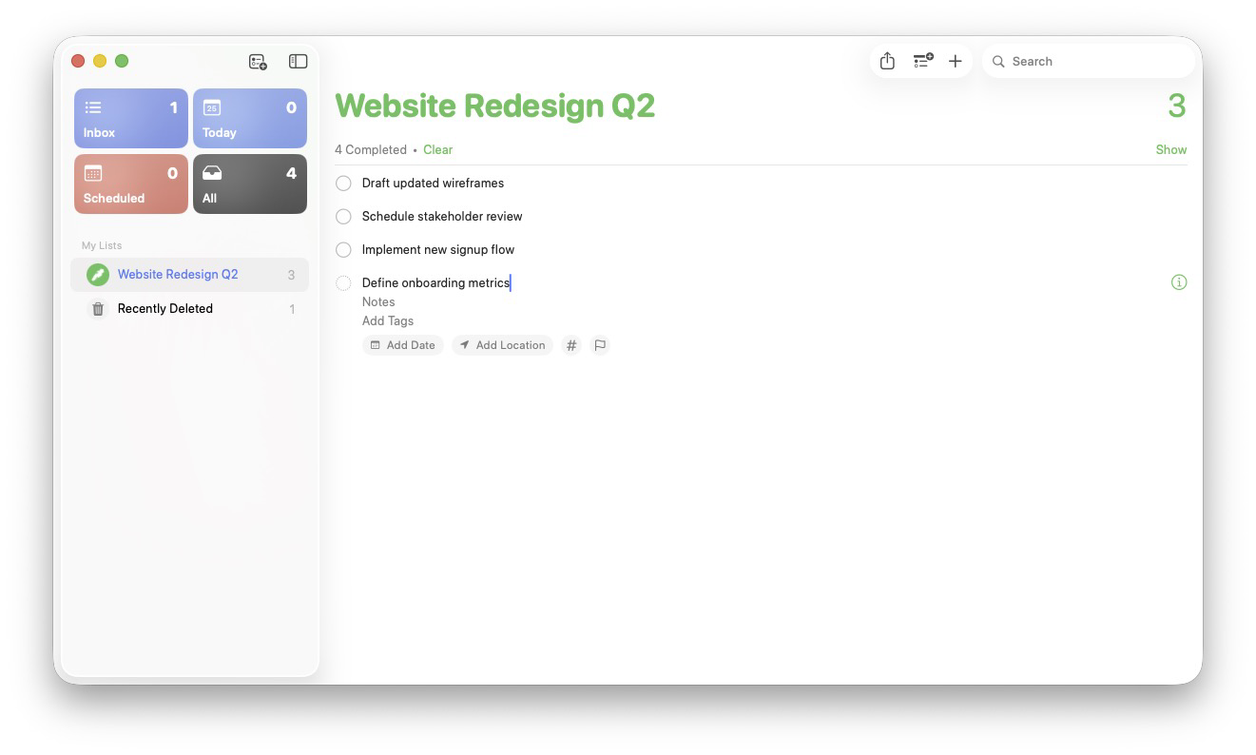

- [X] CH04-MU02 — Reminders Project-Specific Task View

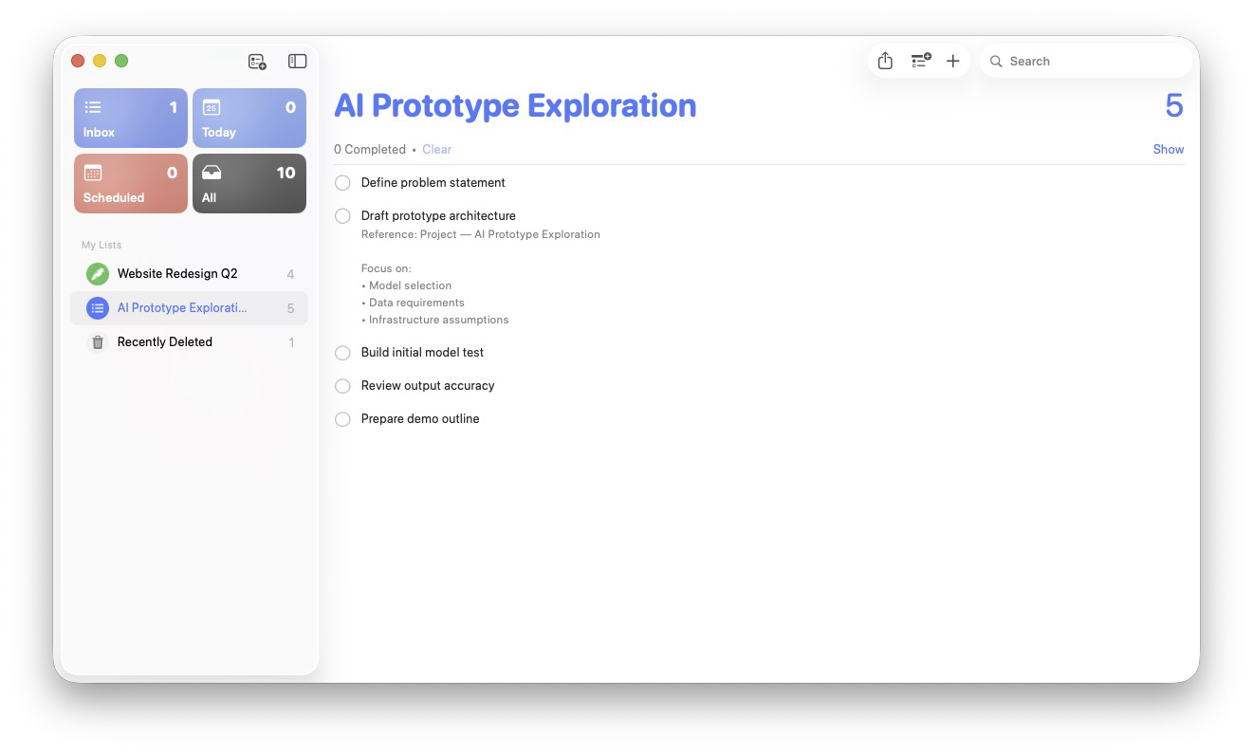

- [X] CH05-MU01 — Quick Capture Shortcut Flow

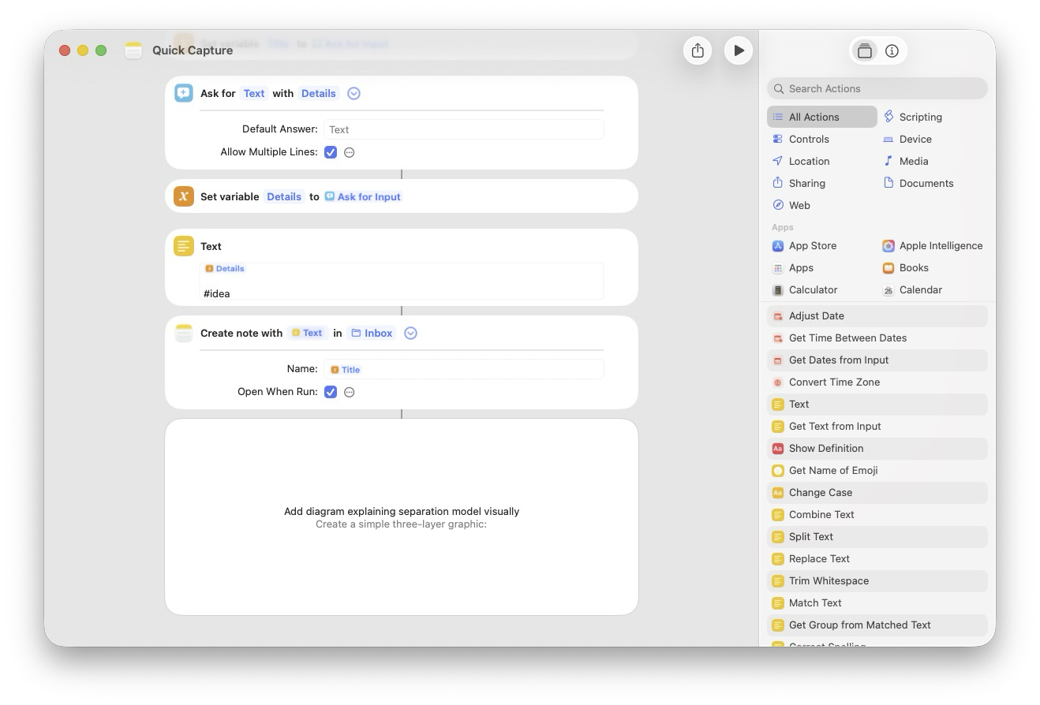

- [X] CH05-MU02 — Send to Reminders Shortcut

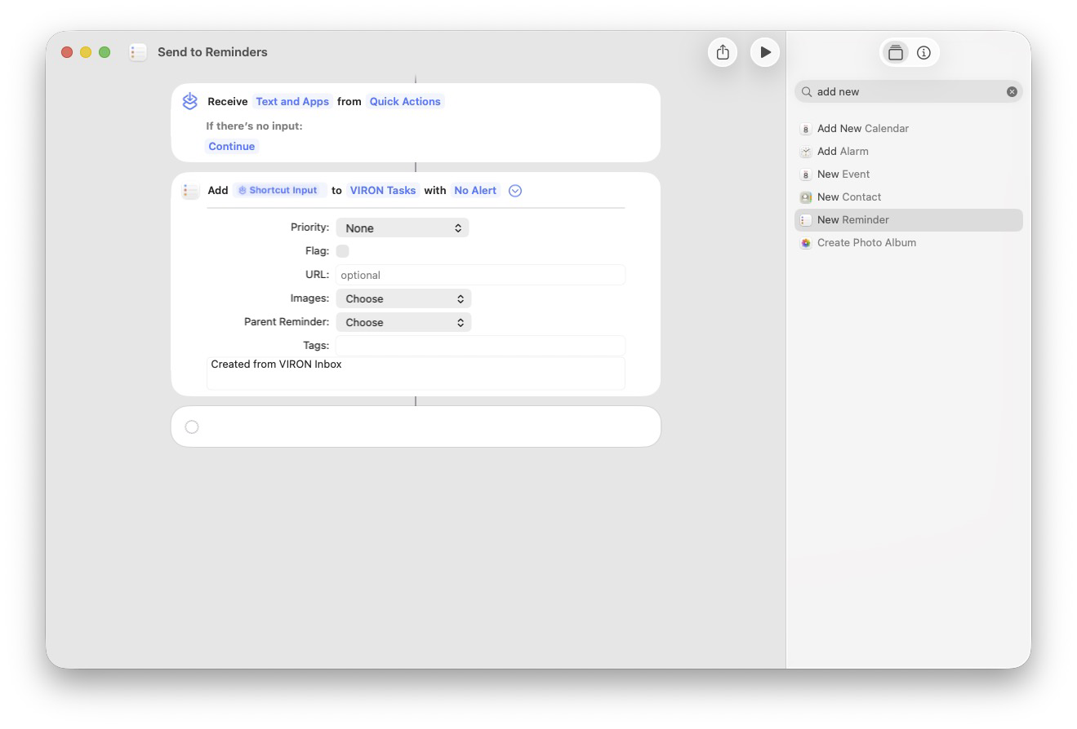

CH05-MU02 — Send to Reminders Shortcut

This shortcut converts a processed idea into an actionable task.
When reviewing items in the Inbox, highlight any text that represents a concrete action and run the Send to Reminders shortcut. The selected text becomes the title of a new reminder in the VIRON Tasks list.
Only items that require execution should be sent to Reminders. Everything else remains in Notes for reference, development, or archiving. This maintains a clear boundary between ideas and commitments.

- [X] CH05-MU03 — Daily Planning Shortcut

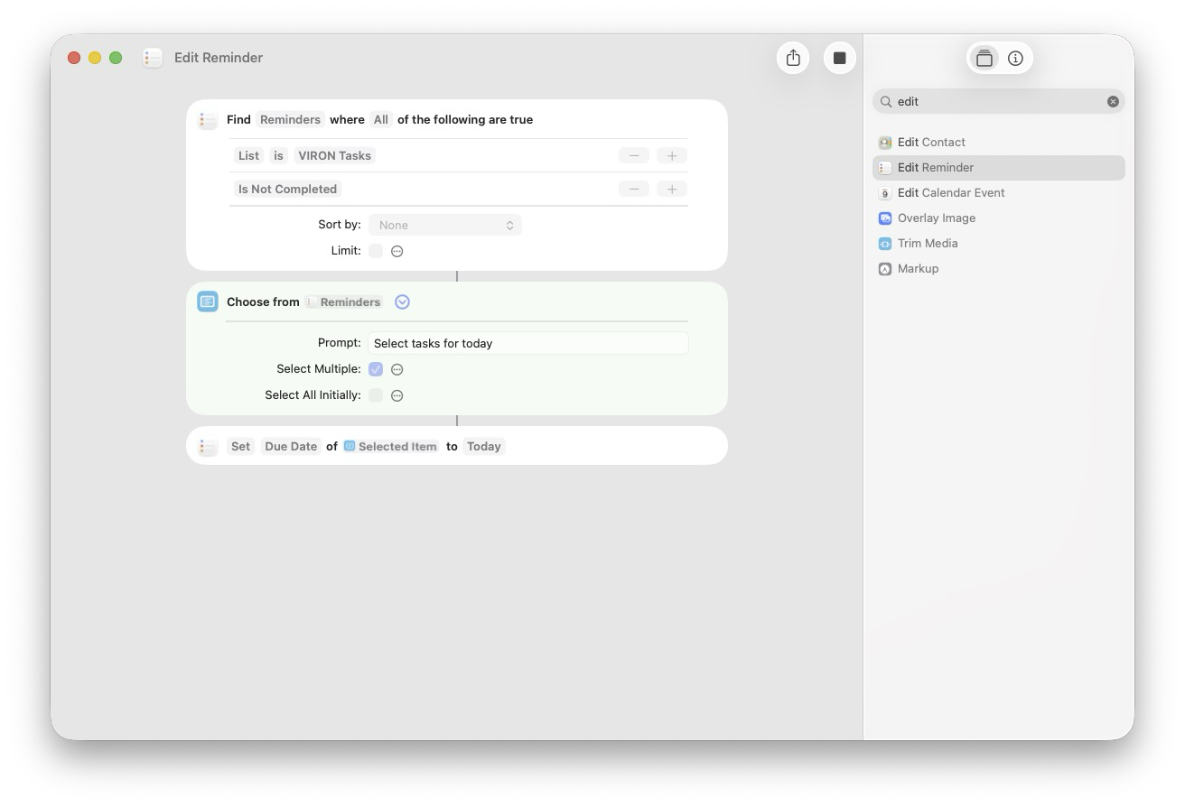

Caption for the Book
Daily Planning Shortcut
This shortcut displays all unfinished tasks and allows you to select the ones that will be completed today. The selected tasks are automatically assigned a due date of today, causing them to appear in the Reminders “Today” view. This creates a lightweight daily planning ritual without requiring a separate planning tool.

- [X] CH05-MU04 — Weekly Reset Shortcut

Instead of a shortcut screenshot, just add this text –

Weekly Reset is performed directly inside Apple Reminders rather than through automation. The goal of the reset is to review unfinished work, remove stale urgency, and restore clarity before the next week begins. By reviewing the key reminder views in sequence, you ensure that no task is forgotten and that the coming week starts with a realistic plan.

Weekly Reset Steps
- Review Inbox
Process captured items and move them into the appropriate project list.
- Review Today
Complete finished tasks and reschedule anything that was not completed.
- Review Scheduled
Confirm that upcoming tasks still belong on the dates assigned to them.
- Review Flagged
Remove flags that are no longer important and keep only the items that still require special attention.
- Review VIRON Tasks
Return to the master task list and confirm that it reflects the work that actually matters going into the next week.

- [X] CH05-MU05 — Shortcut Architecture Concept Diagram

Figure X. Shortcut Automation Within the VIRON System Architecture

- [X] CH06-MU01 — Weekly Review Structure Overview
Figure X. Structure of the Weekly Review Process

- [X] CH07-MU01 — Unified Architecture Diagram

Figure X. Unified Architecture of the VIRON System

Caption for the Book
Unified Architecture Diagram
The VIRON system separates capture, organization, execution, and knowledge into distinct layers. Ideas enter through the Inbox, become structured work through projects and tasks, and ultimately evolve into long-term knowledge within the Library. This architectural separation preserves clarity and prevents systems from collapsing under complexity.

- [X] CH08-MU01 — Library Folder (Mature State)

Figure X. Mature Folder Structure of the VIRON Knowledge Library
Caption: Library Folder (Mature State)
Over time, completed work produces insights. The Library becomes a structured collection of atomic notes that capture principles, observations, and lessons learned from projects.

- [X] CH09-MU01 — Failure Mode Example

Figure X. Failure Mode When System Layers Are Skipped

- [X] CH13-MU01 — Maturity Model Diagram

Figure X. Maturity Model of the VIRON System

- [X] CH14-MU01 — Team Adaptation Diagram

- [X] CH15-MU01 — 90-Day Roadmap

Figure X. 90-Day Roadmap for Implementing the VIRON System
